Course: High Performance Computing Lab

Practical No 1

PRN: 22510044
Name: Ritesh Patil
Batch: B8

Title: Introduction to OpenMP

Problem Statement 1 – Demonstrate Installation and Running of OpenMP code in C.
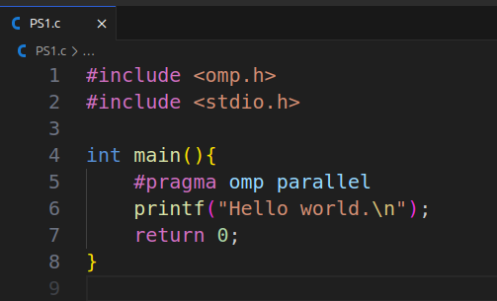

Problem Statement 2 – Print ‘Hello, World’ in Sequential and Parallel in OpenMP
We first ask the user for number of threads – OpenMP allows to set the threads at runtime. Then, we print the Hello, World in sequential – number of times of threads count and then run the code in parallel in each thread.
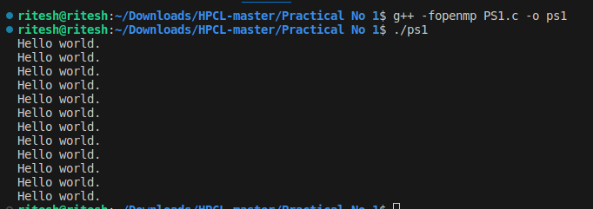
Code snapshot:
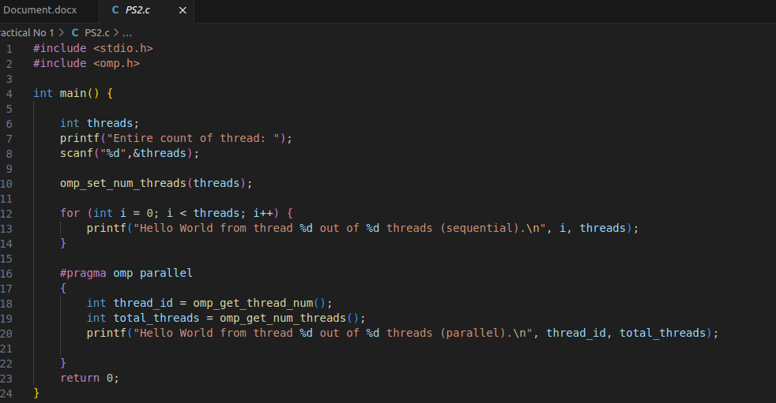
Output snapshot:
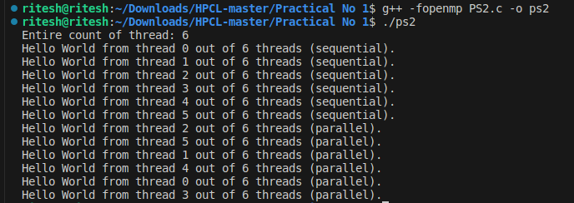

GitHub Link: https://github.com/ritesh6569/HPCL

Problem statement 3: Calculate theoretical FLOPS of your system on which you are running the above codes.
Elaborate the parameters and show calculation.
- Clock speed = 4.5 GHz
- core = 6
- FLOPs per cycle = 16
GFLOPSFLOPS=6×4.5×16= 432 GFLOPS

